 

**Placement Empowerment Program**

**Cloud Computing and DevOps Centre**

**Use Cloud Storage**

**“*Create a storage bucket on your cloud platform and***

***upload/download files. Configure access permissions for the bucket.*”**

Name: **ABINAYA S** DEPARTMENT: **IT**



**Introduction**

Cloud storage is a scalable and reliable solution for storing and managing data in the cloud. It enables users to store, retrieve, and share files efficiently without the need for on-premises hardware. Cloud storage services offer features like versioning, encryption, access control, and lifecycle management, making them ideal for various applications, from backups to data analytics

**Overview**

This Proof of Concept (POC) demonstrates how to create a cloud storage bucket, upload/download files, and configure access permissions. The POC will utilize **Amazon S3 (Simple Storage Service)** as the cloud storage platform, allowing users to securely manage their data. The same principles can be applied to other cloud providers like Google Cloud Storage or Azure Blob Storage.

**Objective**

**The primary objectives of this POC are:**

* **Create a storage bucket** in AWS S3.
* **Upload and download files** to/from the bucket.
* **Configure access permissions** to manage who can read, write, or delete objects in the bucket.
* **Test access control** by restricting or granting permissions to specific users or groups.

**Important Concepts**

* **Scalability:** Cloud storage grows with demand, eliminating the need for additional infrastructure.
* **Security:** Configurable access control and encryption protect sensitive data.
* **Durability & Reliability:** AWS S3 provides high availability and data redundancy.
* **Cost-Effectiveness:** Pay only for the storage used, reducing overall costs.
* **Easy Integration:** Cloud storage can be integrated with other cloud services like AWS Lambda, CloudFront, and RDS for advanced applications.

**Step-by-Step Overview**

**Step1:**

Go to the AWS Management Console, Search for and click on S3

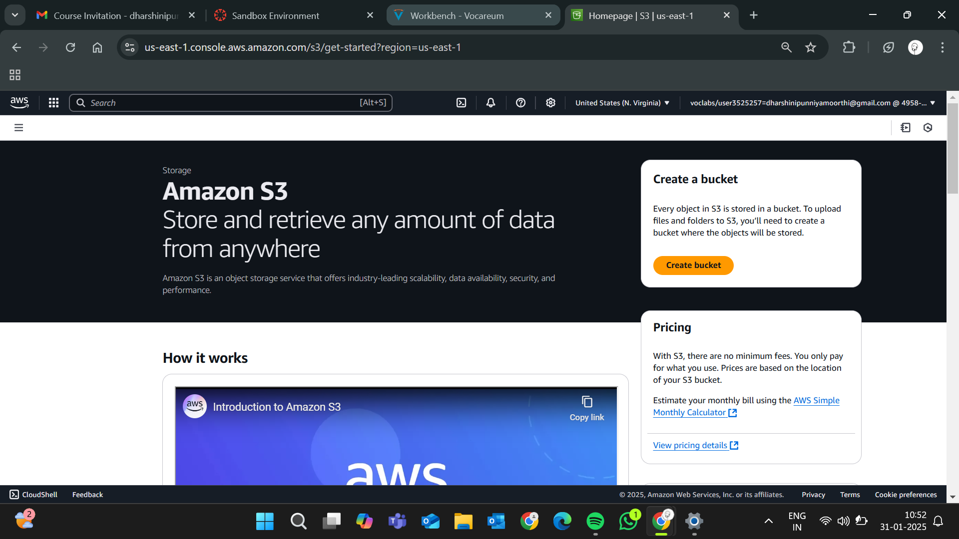

**Step 2 :**

**Create an S3 Storage Bucket**

1. Navigate to **Amazon S3** service.
2. Click on **"Create bucket"** and provide a unique bucket name

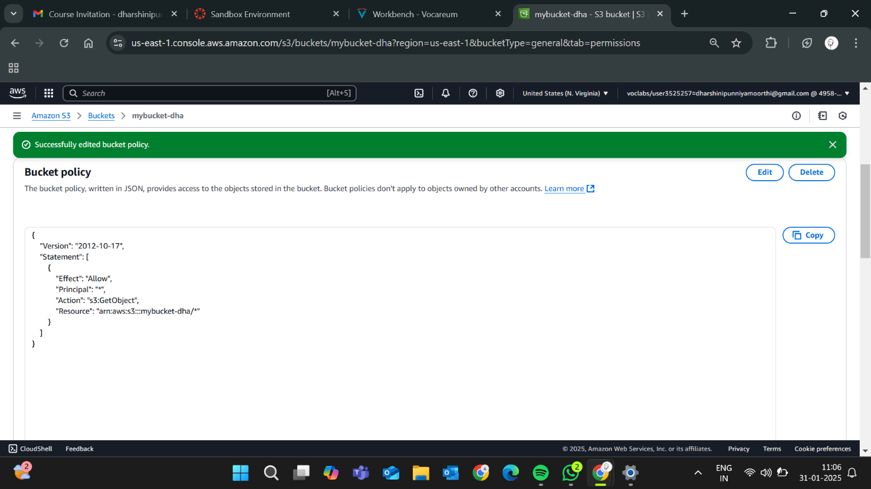

**Step 3:**

Leave **"Block all public access"** enabled for now (you can modify it later).

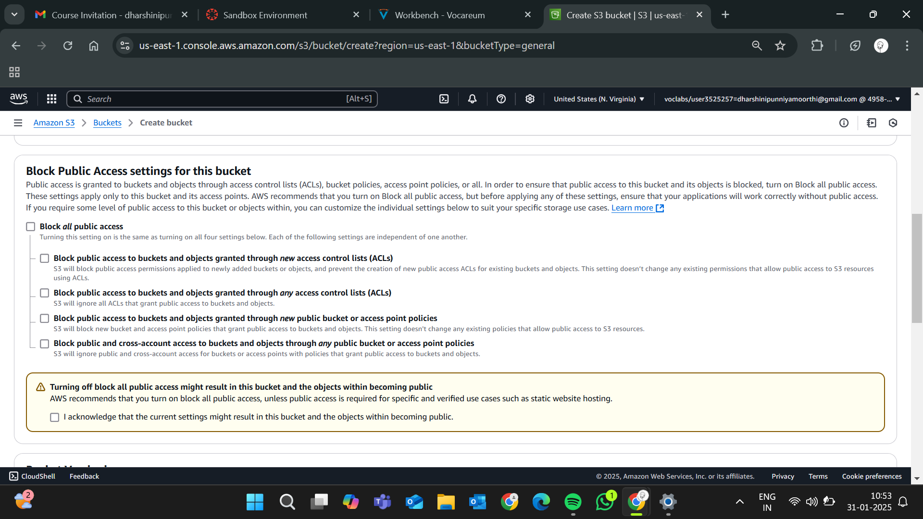

**Step 4:**

Click "Create bucket".

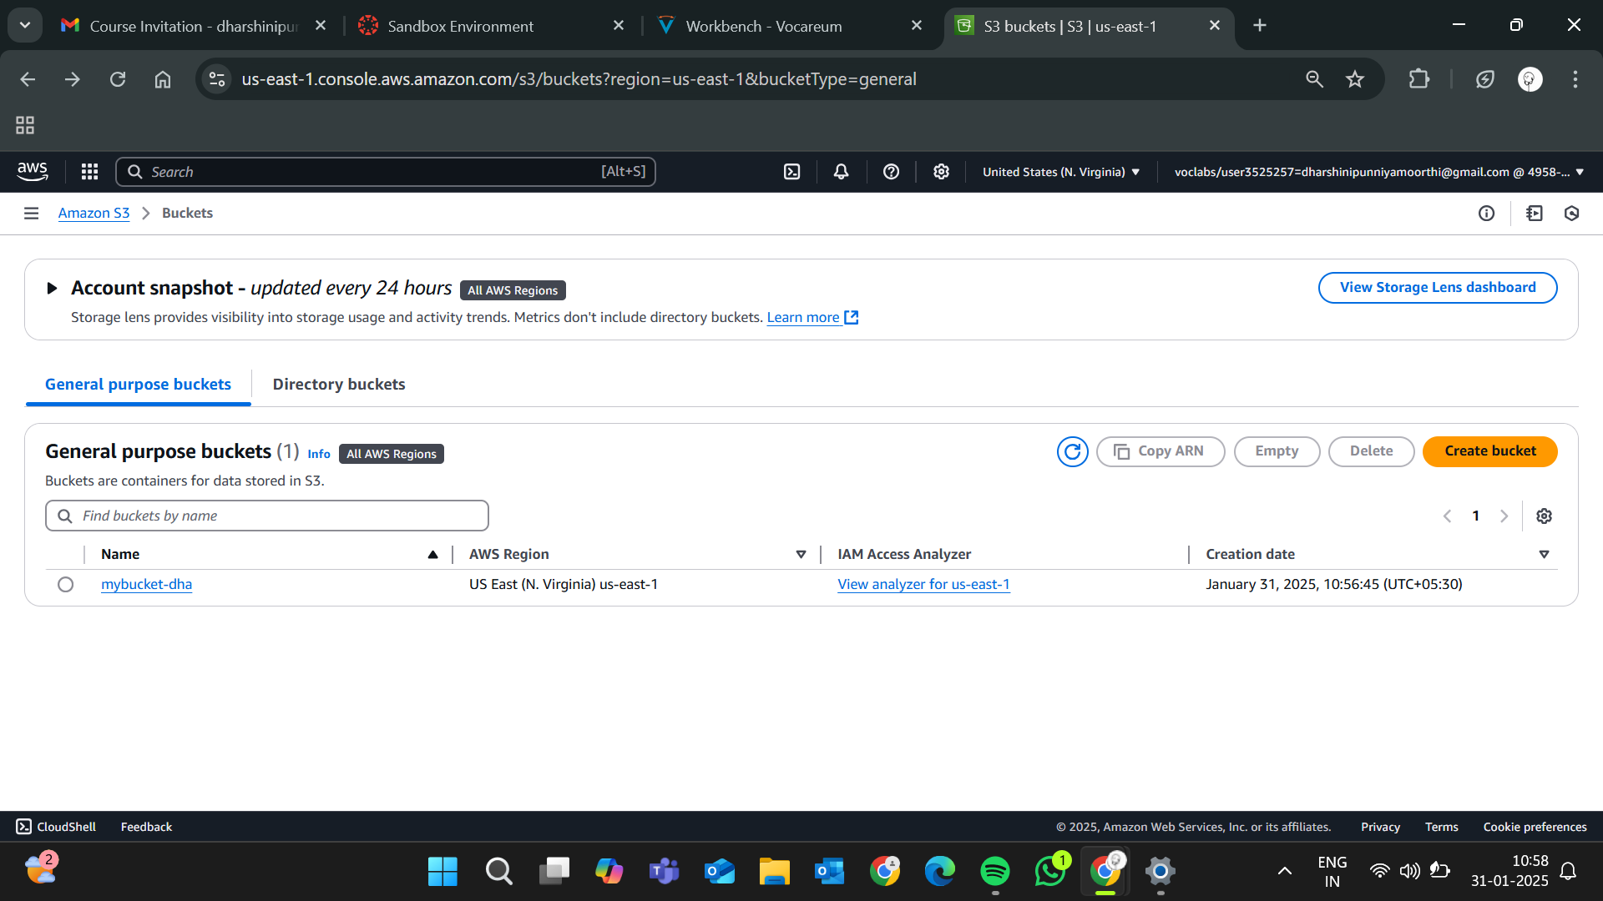

**Step 5:**

Open your newly created bucket from the S3 console.

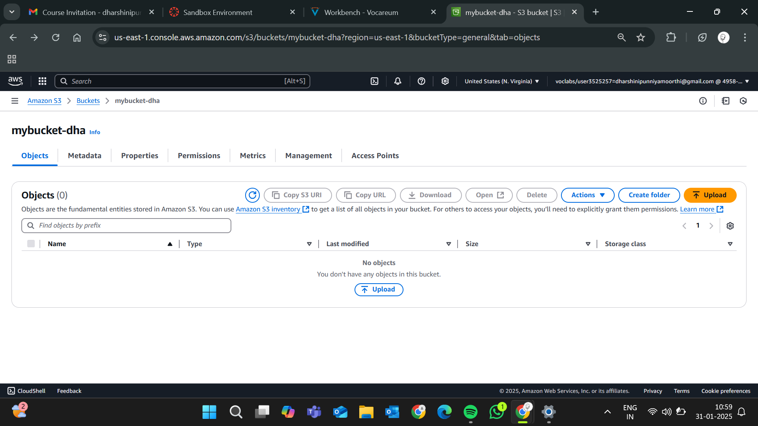

**Step 6:**

Click "Upload" and then,

Drag and drop your file(s) or use the Add files button.Click Upload to complete.

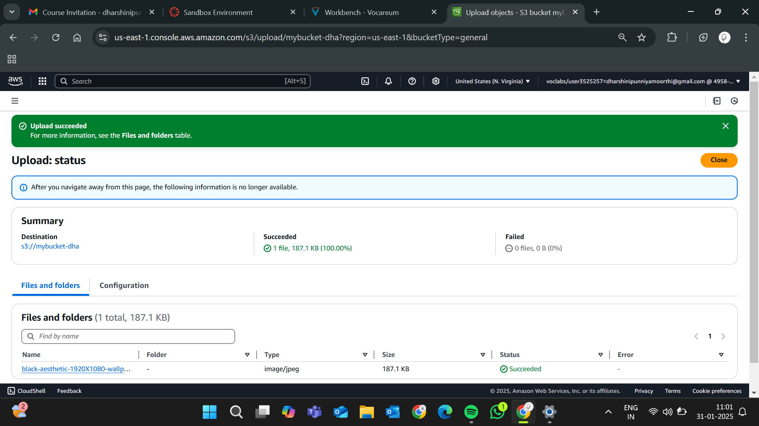



**Step 7:**

Go to the uploaded file in your bucket. Click the file name to open its details. Select Download to save the file locally.

**Step 8:**



* Open your bucket and navigate to the **"Permissions"** tab.
* Under Block public access, click Edit and uncheck **"Block all public access"**. Confirm by typing **"confirm"** and save.

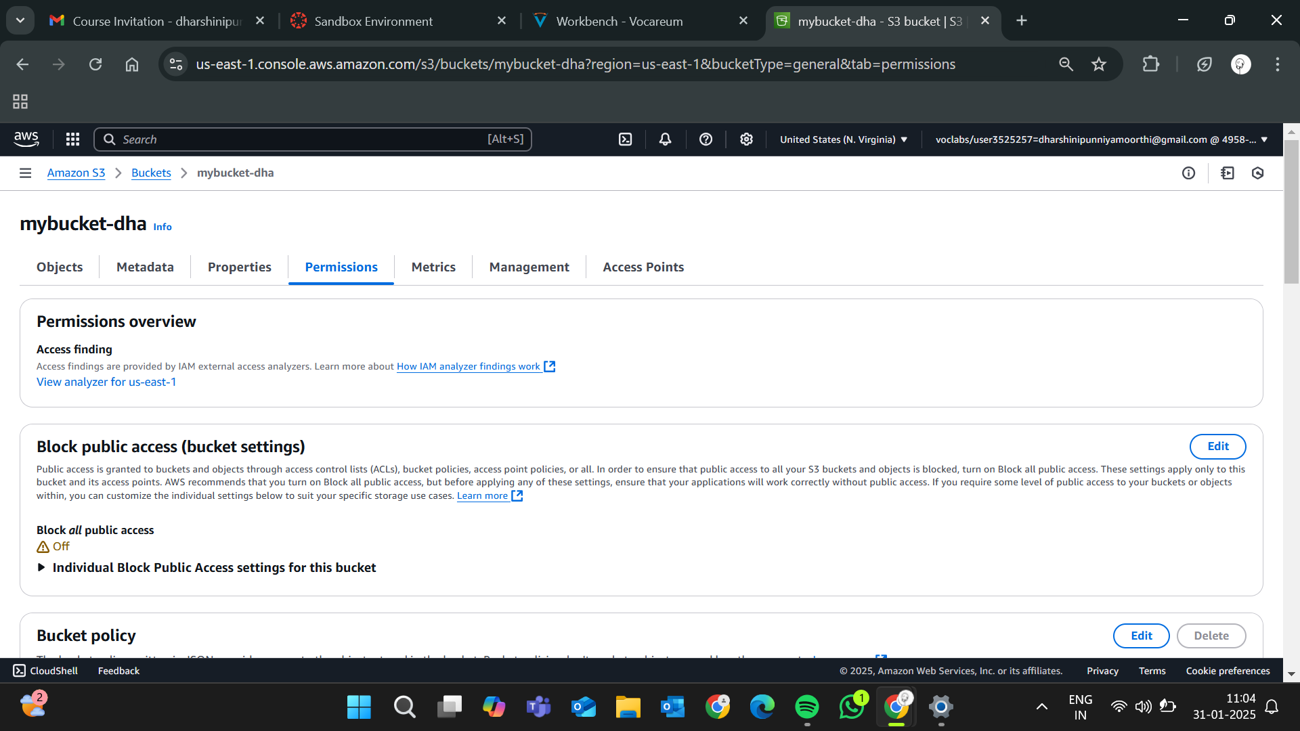

**Step 9 :**

In the **"Permissions"** tab, scroll to Bucket Policy and click Edit.Replace your-bucket-name with your actual bucket name.Save changes.

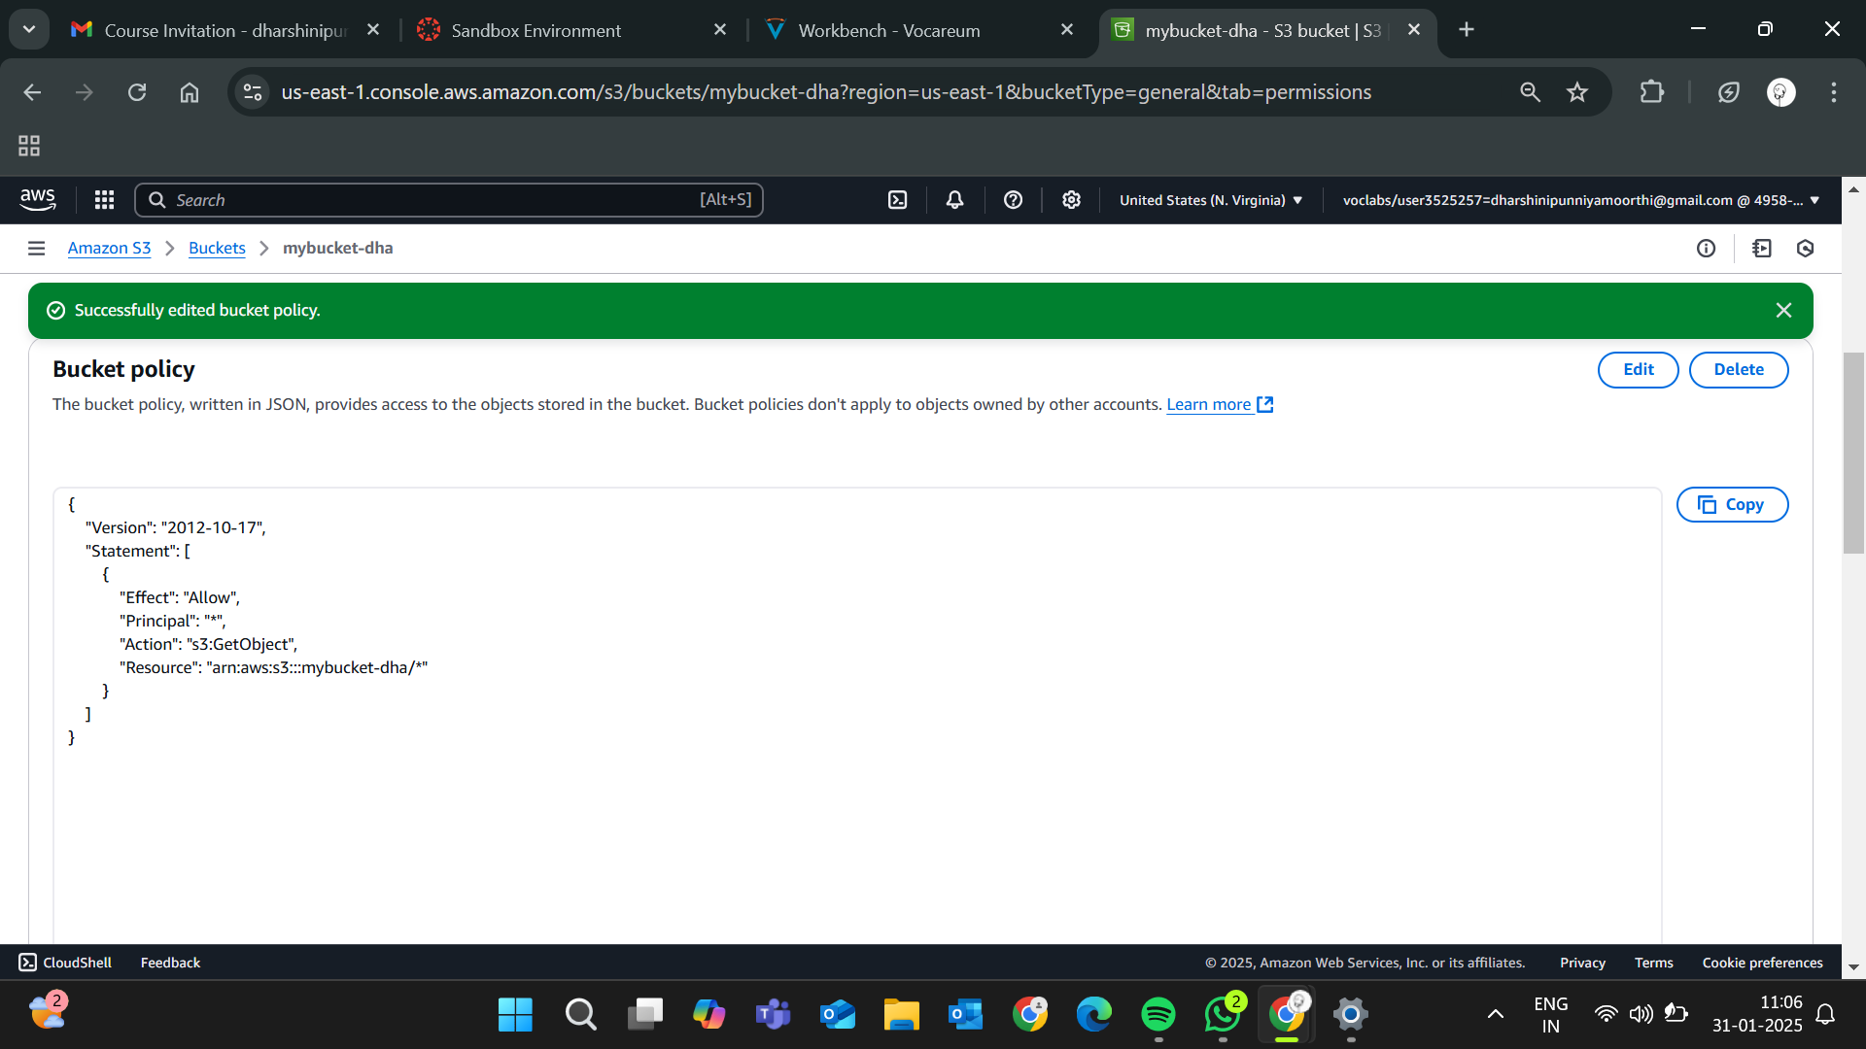

**Step10:**

Use the S3 bucket URL or public file URL to test access permissions.

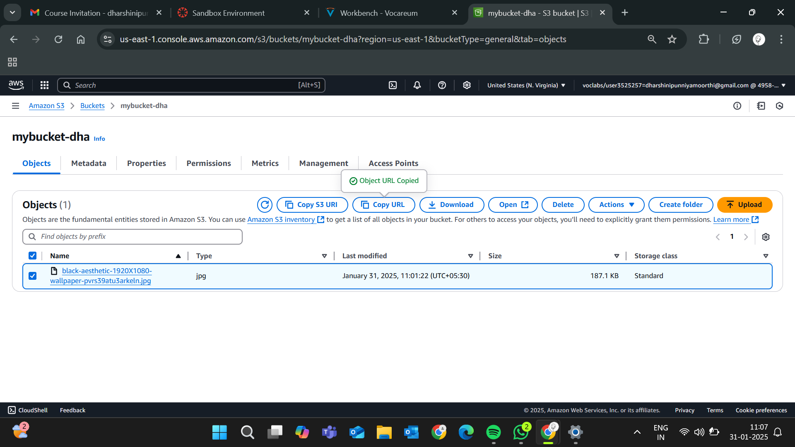

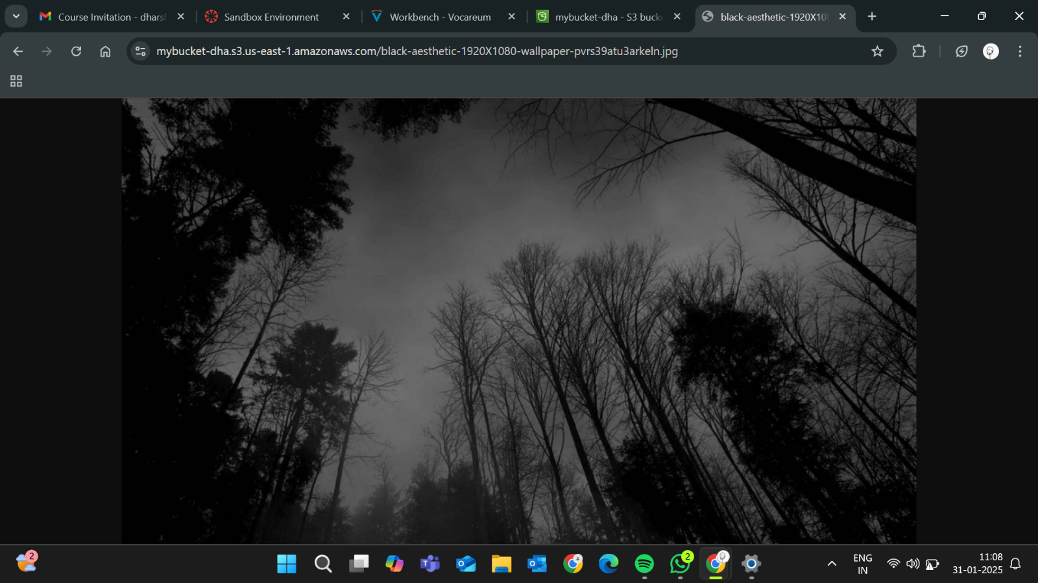

**Expected Outcome:**

**By completing this POC, you will:**

1. Successfully create an AWS S3 bucket and perform file upload/download operations.
2. Configure and validate access permissions, ensuring secure or public access as needed.

Gain a solid understanding of S3's functionality, enabling its use in real-world cloud-based applications